ASSIGNMENTS – Cyber Security Threat Intelligence

By John B. Webb IV

Assignment #1 – Cybersecurity Concepts

Tasks

• What is the role of threat intelligence in cybersecurity defense strategies?

Threat intelligence in cybersecurity involves collecting, analyzing, and applying information about existing and potential cyber threats to protect an organization from security breaches. This proactive approach is crucial for anticipating and mitigating risks before they materialize into attacks.

Purpose

• Clarify – Understand the concept of threat intelligence and its significance in proactive

cybersecurity measures.

• Summarize – Be able to explain how threat intelligence is gathered, analyzed, and used

to protect against cyber threats.

Assignment

• In a text box

o Describe what threat intelligence involves, including the data types collected and how it informs secure security operations and strategy.

Describe what threat intelligence involves, including the types of data collected and how it informs security operations and strategy.

**Types of Data Collected in Cybersecurity Threat Intelligence**

1. **Strategic Intelligence:** Insights into the broader cyber threat landscape, including trends, cybercriminals' motivations, and potential regulatory changes affecting cybersecurity.
2. **Tactical Intelligence:** Specific details on the tactics, techniques, and procedures (TTPs) used by cyber attackers, which can inform defensive strategies.
3. **Operational Intelligence:** Information about specific cyberattacks or campaigns, including details about the attackers, their methods, and the infrastructure they use.
4. **Technical Intelligence:** Data points such as indicators of compromise (IoCs), which include malicious IP addresses, URLs, file hashes, and malware signatures. This intelligence type is used to enhance and configure cybersecurity tools and defenses.

**Impact on Security Operations and Strategy**

• **Proactive Security Measures:** By understanding attacker methods and emerging threats, organizations can create defenses tailored to block those threats before they are exploited.

• **Enhanced Incident Response:** Real-time threat intelligence provides essential context during an attack, helping to identify the attack's nature and origin and guiding the response team on how to counteract it effectively.

• **Risk Assessment and Management:** Operational and strategic intelligence helps identify and prioritize potential threats based on their likelihood and impact, which aids in better resource allocation and risk management.

• **Policy and Compliance Strategy Development:** Comprehensive threat intelligence assists in shaping effective security policies and strategies that tackle the most significant threats while adhering to regulatory requirements.

•

Screenshots

o Provide diagrams or conceptual frameworks showing the threat intelligence

lifecycle or examples of threat intelligence reports.

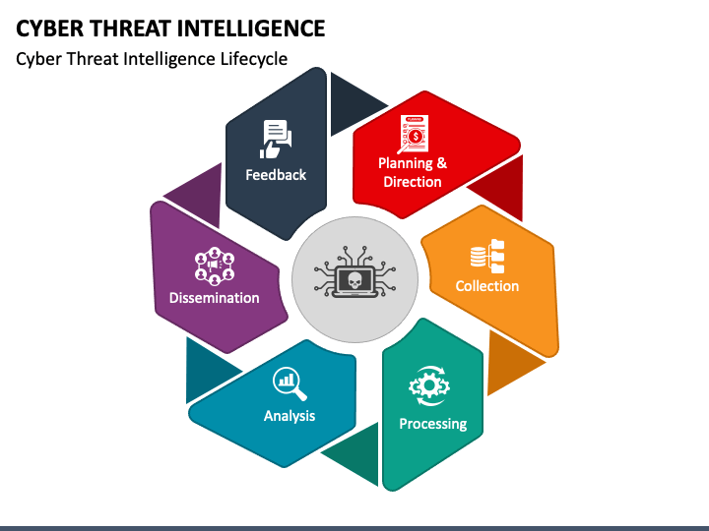

Assignment #2 – Cybersecurity Concepts

Tasks

• Explain the difference between tactical, operational, and strategic threat intelligence.

Purpose

• Clarify – Understand the distinctions and applications of different levels of threat

intelligence.

• Summarize – Be able to describe specific examples of how each type of intelligence is

used within an organization.

Assignment

• In a text box

Discuss the specific focus and time horizon of tactical, operational, and strategic

threat intelligence, including how each influences cybersecurity decisions at

different levels of an organization.

**Tactical Threat Intelligence**

**Focus:** Tactical threat intelligence deals with the specifics of immediate threats, such as threat actors' tactics, techniques, and procedures (TTPs). It often revolves around indicators of compromise (IoCs) that can be used to detect and respond to threats in real-time.

**Time Horizon:** Short-term, typically focusing on immediate threats and responses. It’s actionable within days or weeks.

**Impact on Organization:** Tactical intelligence is used primarily by technical teams such as security operations centers (SOCs) to enhance defensive mechanisms. For example, they update firewalls, tweak intrusion detection systems, or patch identified vulnerabilities that are being exploited in the wild.

**Operational Threat Intelligence**

**Focus:** This level of intelligence examines the broader context of cyber threats, including adversaries' motivations, intents, and campaign details. It aligns immediate tactics with longer campaigns to understand the sequence and significance of attacks.

**Time Horizon:** Medium-term, actionable over weeks to months. It helps organizations prepare for and mitigate against ongoing or upcoming attacks.

**Impact on Organization:** Operational intelligence is crucial for incident response and security teams to strategize and prioritize responses to ongoing or anticipated attacks. For instance, teams can prepare by staging resources accordingly and planning countermeasures if a multi-stage attack is expected.

**Strategic Threat Intelligence**

**Focus:** Strategic threat intelligence provides a high-level overview of the cyber threat landscape, including trends, potential risks, and predictions. It’s less about technical details and more about understanding the risk landscape to inform business decisions.

**Time Horizon:** Long-term, often looking at trends and predictions over the years.

**Impact on Organization:** This type of intelligence is typically consumed by senior leadership to guide risk management and policy-making decisions. It helps formulate a security strategy that aligns with the organization’s business objectives and risk tolerance. For example, it might influence decisions on investing in new security technologies or adjusting cybersecurity policies to mitigate risks associated with emerging technological trends.

Assignment #3 – Cybersecurity Concepts

Tasks

• What are the common sources of threat intelligence?

1. **Open Source Intelligence (OSINT):**
   * **Description:** Publicly available data from the internet, including websites, forums, social media, and more.
   * **Strengths:** Broad coverage; no cost; can provide early warnings about new threats.
   * **Limitations:** Voluminous and unverified data requires significant effort to filter and verify relevance and accuracy.
2. **Human Intelligence (HUMINT):**
   * **Description:** Information gathered from human sources, such as insiders, experts, or others with access to valuable data.
   * **Strengths:** Can provide context and insights not available from automated systems.
   * **Limitations:** Can be subjective; potentially biased; may involve ethical and legal considerations.
3. **Technical Intelligence (TECHINT):**
   * **Description:** Derived from technical artifacts like malware samples, system logs, or network captures.
   * **Strengths:** Highly specific; directly applicable to improving defenses; helps understand attacker TTPs (Tactics, Techniques, and Procedures).
   * **Limitations:** Requires technical expertise to interpret and can be resource-intensive to collect and analyze.
4. **Industry Sharing Platforms (ISACs/ISAOs):**
   * **Description:** Information Sharing and Analysis Centers (ISACs) and Organizations (ISAOs) provide industry-specific threat data.
   * **Strengths:** Sector-specific relevance; collaborative defense benefits; sharing of best practices.
   * **Limitations:** This may have delayed information depending on community members' activity level and engagement.
5. **Commercial Threat Intelligence Services:**
   * **Description:** Paid services that offer curated threat intelligence feeds, reports, and analytics.
   * **Strengths:** Comprehensive and timely information; often includes analysis and actionable advice.
   * **Limitations:** It can be expensive, and it may not cover all niche or emerging threats specific to certain industries or technologies.

Purpose

• Clarify – Identify and evaluate the primary sources from which threat intelligence can be

derived.

• Summarize – Be able to list and describe the strengths and limitations of each source in

contributing to a comprehensive threat intelligence picture.

Assignment

• In a text box

o List all the different types of TTPs, IOCs, IOAs, etc., and discuss their relevance

and reliability. Include the Pyramid.

**Key Terms and Their Relevance:**

* **Tactics, Techniques, and Procedures (TTPs):** These describe the behavior of threat actors. Understanding TTPs helps anticipate attacker moves and strengthen defenses accordingly.
* **Indicators of Compromise (IoCs):** Include IP addresses, URLs, hashes of malicious files, etc. They are crucial for detecting and responding to incidents quickly.
* **Indicators of Attack (IoAs):** These focus on detecting the intent of an attack rather than the artifacts (like IoCs). They help catch attacks earlier in the kill chain.

**The Pyramid of Pain:**

This framework illustrates the indicators that can be used in cyber defense and the difficulty each type imposes on an attacker when denied.

* **Hash Values:** Easy for attackers to change; relatively simple to detect.
* **IP Addresses:** Also easy to alter; often caught by network defenses.
* **Domain Names:** More difficult to continually change; better longevity in threat intelligence.
* **Network/Host Artifacts:** Includes tools or malware binaries; harder for attackers to modify.
* **TTP:** Most challenging for attackers to modify; identifying and mitigating against these requires deep analysis and understanding.

• Screenshots

o Provide screenshots or examples of tools or databases used to collect each type of

intelligence.

OSINT: Shodan

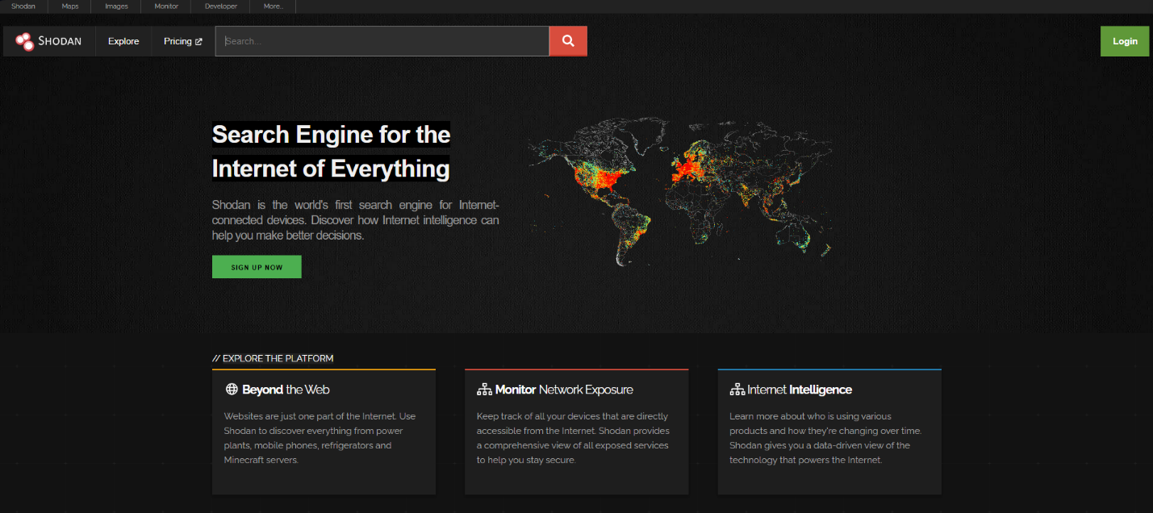

HUMINT: Linkedin



TECHINT: VirusTotal

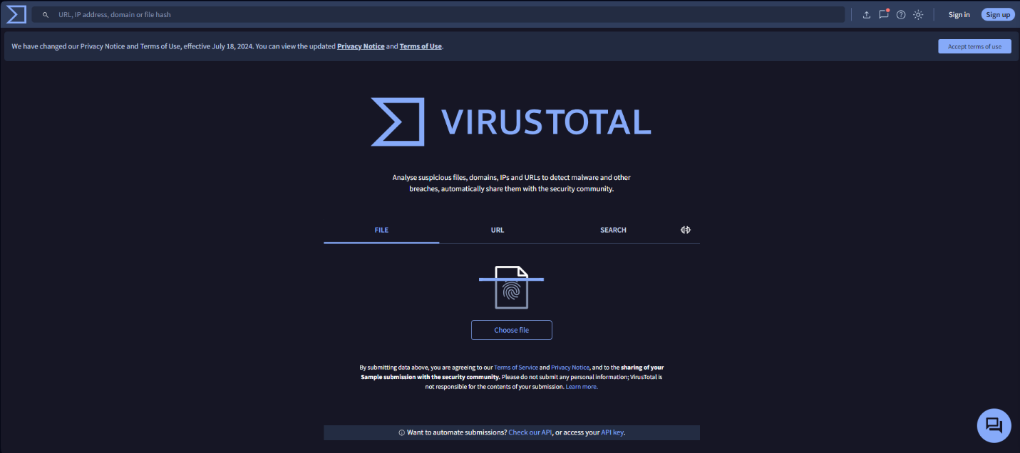

Industry Sharing Platforms: Automotive ISAC

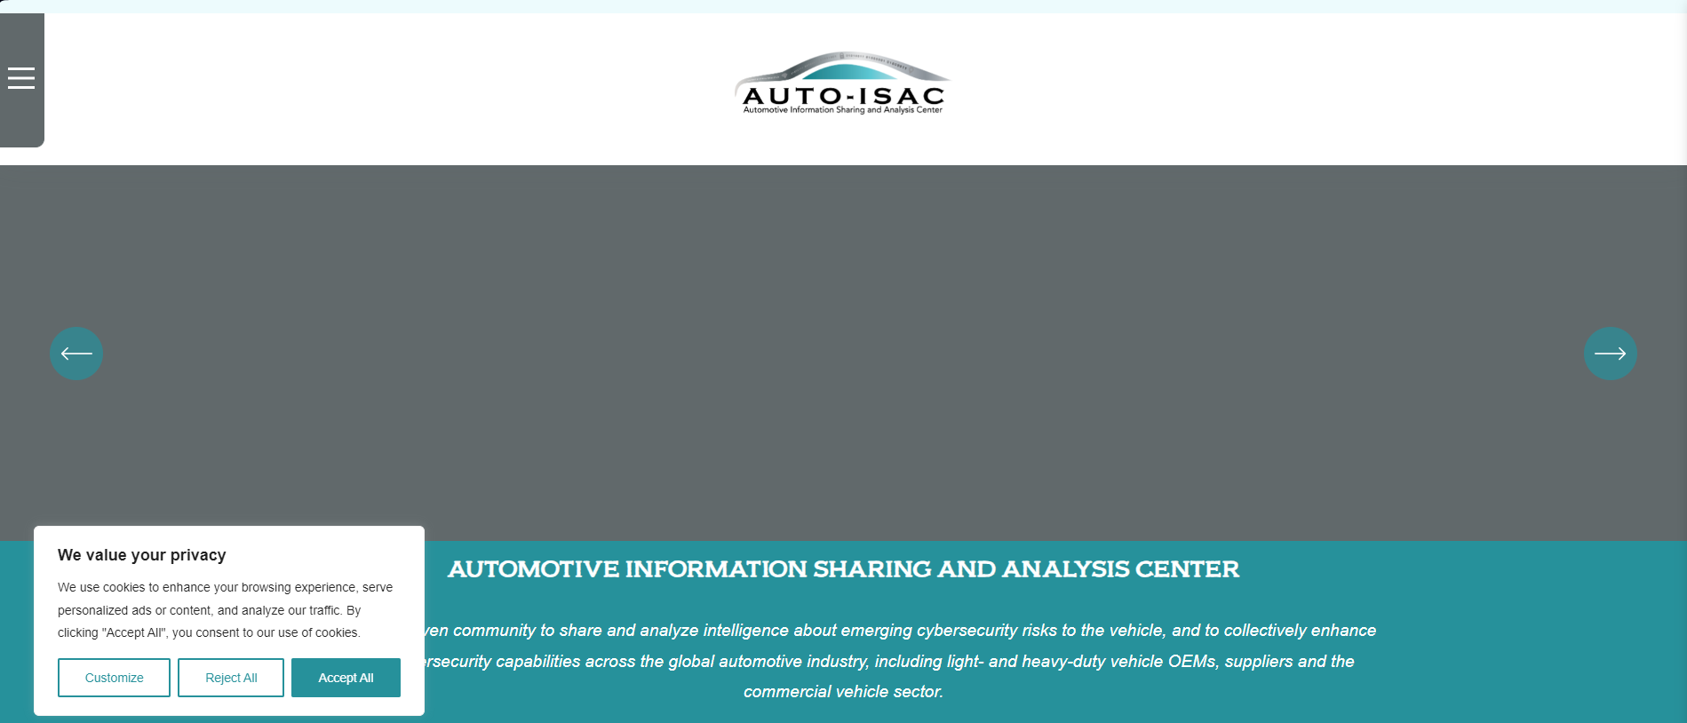

Commercial: Mandiant Intelligence

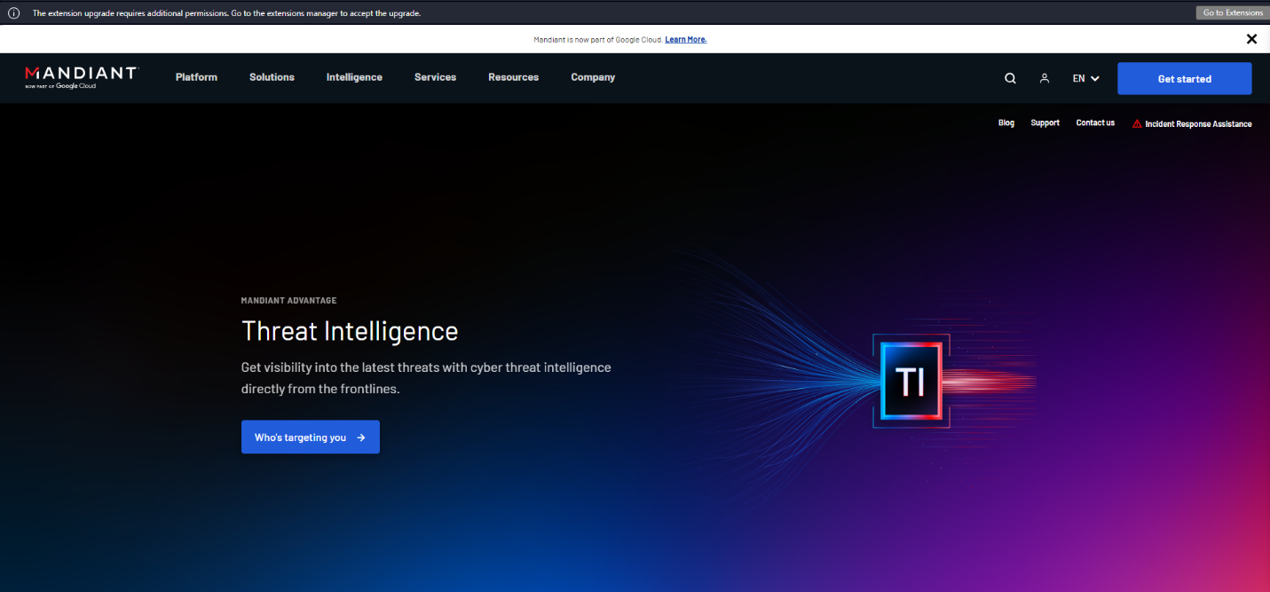

Assignment #4 – Cybersecurity Concepts

Tasks

• How can organizations effectively integrate threat intelligence into their security

operations center (SOC)?

Purpose

• Clarify – Discuss the integration of threat intelligence into security operations.

• Summarize – Be able to describe how threat intelligence can enhance the capabilities of

a SOC and improve incident response.

Assignment

• In a text box

Detail the process of incorporating threat intelligence into SOC workflows,

including real-time data feeds, alerting systems, and how it assists in threat

detection and response.

**Process of Integrating Threat Intelligence into SOC Workflows**

1. **Selection of Relevant Threat Intelligence Sources**
   * Identify and subscribe to credible threat intelligence feeds that align with the organization's industry, threat landscape, and specific security needs. This may include commercial feeds, open-source intelligence (OSINT), industry-specific alerts, and governmental advisories.
2. **Integration with Security Information and Event Management (SIEM) Systems**
   * Feed selected threat intelligence into the SIEM system to enrich existing data. The integration allows for the correlation of incoming logs and events with known indicators of compromise (IOCs), tactics, techniques, and procedures (TTPs) from threat actors. This enhances the detection capabilities by flagging potential threats that match the intelligence criteria.
3. **Real-Time Data Feeds and Alerting Systems**
   * Implement real-time threat intelligence feeds to ensure the SOC team receives up-to-the-minute information about emerging threats and vulnerabilities. Configure the SIEM and other security tools to generate alerts based on matches to these feeds, enabling quicker response times.
4. **Customization of Security Tools and Protocols**
   * Customize security tools to respond to threats automatically based on specific intelligence inputs. This includes updating firewall rules and intrusion detection system (IDS) signatures and implementing automated blocking or containment measures.
5. **Threat Intelligence Platforms (TIPs)**
   * Use a dedicated Threat Intelligence Platform (TIP) to aggregate, analyze, and manage intelligence feeds effectively. A TIP can help sift through the vast amounts of data to identify what is most relevant to the organization.
6. **Training and Awareness**
   * Regularly train SOC analysts on the latest threat trends, intelligence analysis techniques, and the effective use of threat intelligence tools. Ensuring the team understands how to interpret and apply intelligence data is crucial for proactively managing threats.
7. **Incident Response Integration**
   * Incorporate threat intelligence into incident response (IR) protocols to guide the response actions based on the nature of the detected threat. Detailed intelligence can provide insights into the attacker’s methodologies, helping to tailor the response strategy effectively.
8. **Continuous Improvement and Feedback Loops**
   * Establish feedback loops within the SOC to assess the effectiveness of the threat intelligence integration. Regular reviews and updates of the intelligence needs and sources are necessary to stay relevant to the evolving threat landscape.

**Benefits of Integrating Threat Intelligence in SOC**

* **Enhanced Detection Capabilities:** By utilizing external and internal threat intelligence, SOCs can detect complex, sophisticated threats more quickly and accurately.
* **Improved Incident Response:** Access to detailed threat intelligence allows for faster and more informed decision-making during security incidents, reducing the impact of breaches.
* **Proactive Security Posture:** With up-to-date intelligence, organizations can shift from a reactive to a proactive security approach, anticipating and mitigating threats before they manifest.
* **Strategic Security Planning:** Long-term threat intelligence can inform strategic decisions, guiding the development of more robust security frameworks and investment in security technologies.